Computer Graphics, Lab Assignment 2
Handed out: March 30, 2026
Recommended due: 15:00, April 6 2026
Hard due: 23:59, April 6, 2026 (NO SCORE for late submissions!)
Submit your assignment only through the lecture home at portal.hanyang.ac.kr.
Submit a single zip [studentID]-[assignment#].zip file containing two source files.
- Write down a Python program to draw a regular 12-sided polygon (dodecagon, 정12각형).
  - Set the window title to [studentID]-[assignment#]-[prob#] (e.g. 2017123456-2-1) and the window size to (480,480).
  - Use np.linspace() (or np.arrange()), np.cos(), np.sin() to compute the positions of vertices.
  - Do not hardcode the position of each vertex.
  - The 12 vertices should be specified counterclockwise starting from the vertex on the x-axis.
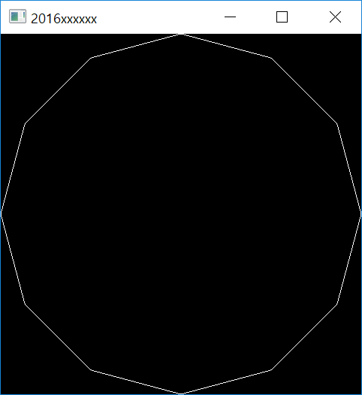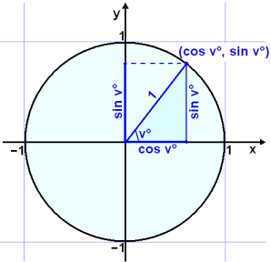
  - If the keys 1, 2, 3, … 9, 0 are entered, the primitive type should be changed.
Hint: Use a global variable to store the primitive type
Key | Primitive Type
1 | GL_POINTS
2 | GL_LINES
3 | GL_LINE_STRIP
4 | GL_LINE_LOOP
5 | GL_TRIANGLES
6 | GL_TRIANGLE_STRIP
7 | GL_TRIANGLE_FAN
8 | GL_QUADS
9 | GL_QUAD_STRIP
10 | GL_POLYGON
  - Use a single .py file - [studentID]-[assignment#]-[prob#].py (e.g. 2017123456-2-1.py)
  - Expected result:
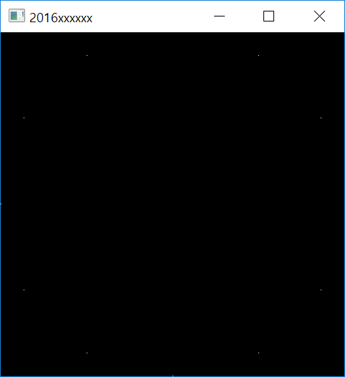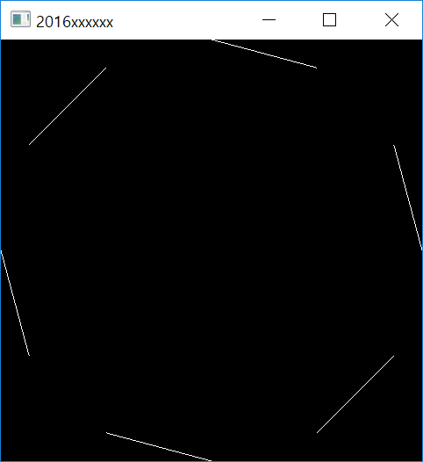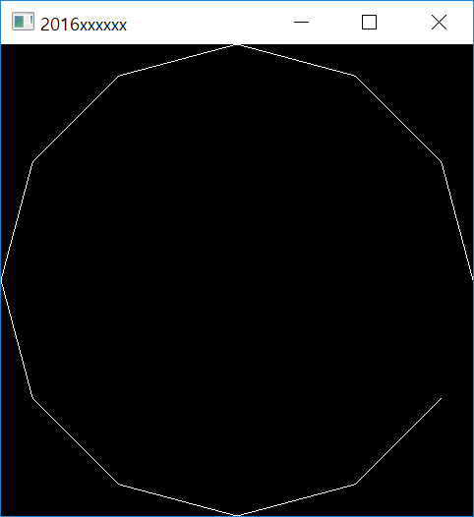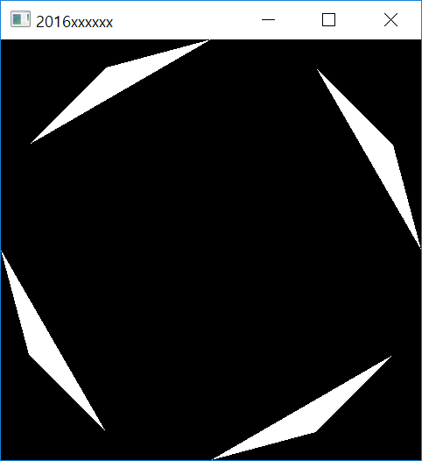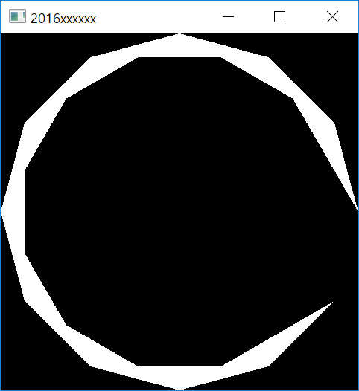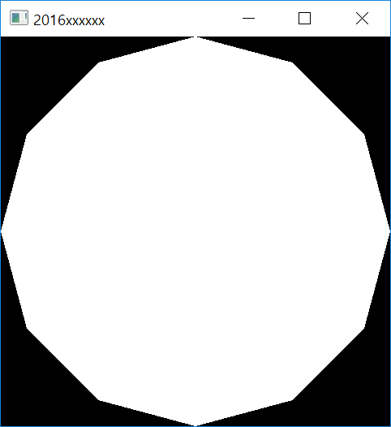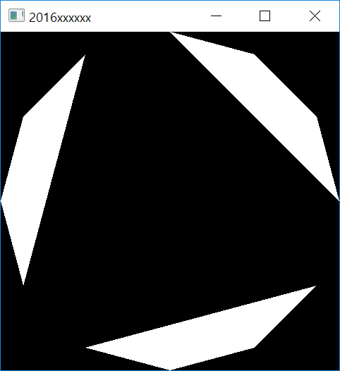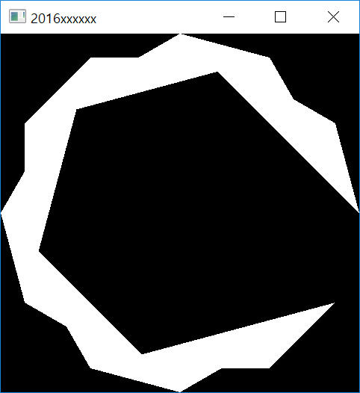
When the program starts
Press ‘1’
Press ‘2’
Press ‘3’
Press ‘4’
Press ‘5’
Press ‘6’
Press ‘7’
Press ‘8’
Press ‘9’
Press ‘0’

- Write down a Python program to draw a rotating triangle.
  - Set the window title to [studentID]-[assignment#]-[prob#].(e.g. 2017123456-2-2) and the window size to (480,480).
  - Draw a triangle using render() function below (DO NOT modify it!).
def render(T):
glClear(GL_COLOR_BUFFER_BIT)
glLoadIdentity()
# draw cooridnate
glBegin(GL_LINES)
glColor3ub(255, 0, 0)
glVertex2fv(np.array([0.,0.]))
glVertex2fv(np.array([1.,0.]))
glColor3ub(0, 255, 0)
glVertex2fv(np.array([0.,0.]))
glVertex2fv(np.array([0.,1.]))
glEnd()
# draw triangle
glBegin(GL_TRIANGLES)
glColor3ub(255, 255, 255)
glVertex2fv( (T @ np.array([.0,.5,1.]))[:-1] )
glVertex2fv( (T @ np.array([.0,.0,1.]))[:-1] )
glVertex2fv( (T @ np.array([.5,.0,1.]))[:-1] )
glEnd()
  - Use a single .py file - [studentID]-[assignment#]-[prob#].py. (e.g. 2017123456-2-2.py)
  - Expected result: Uploaded as LabAssignment2-2.mp4
    - Do not mind the initial angle of the triangle.

